ENGLISH FIRST ADDITIONAL LANGUAGE
GRADE 10
JUNE 2006
TRANSACTIONAL WRITING
PAPER III
TOTAL: 100
TIME: 3 HOURS

QUESTION 1

Write an essay of approximately 200-250 words about one of the following topics. Write topic at the top of your essay.

1.1 The man from Mars
1.2 Everything in life is not good
1.3 The best place I have ever visited
1.4 This is my story
1.5 You are innocent until you are proven guilty. Reflect on this.
1.6 My mother

(40)
QUESTION 2
Begin the answer of this question on a new page.

Read the following article and answer the questions that follow:

School break-in
Staff reporter
During a recent burglary at Rainbow Secondary School, the school staff room was damaged and a large amount of money was stolen. According to a police spokesperson, a learner at the school is thought to have been involved in the incident. An angry Mr B Matubela, chairman of the school governing body, has promised that the school authorities will make an example of the guilty party.

2.1 What was the intention of the reporter who wrote this article?
(1)
2.2 Why do you think didn't the reporter mention the name of the learner who they suspect of this crime?
(1)
2.3 Who do you think broke into the staff room and why?
(2)

Read more about the life and thoughts of the suspect:

Guilty until proved innocent
The chairman of the soccer club phoned me yesterday. Last week, he was going to offer me a full-time contract, this week everything is on hold "until all the unpleasantness has been sorted out", as he put it.

"But I'm innocent, Mr Thomas," I said. "Completely innocent."
He didn't answer straight away, which is how I knew he didn't believe me.

"It's best for the club if we just slow things down for a while, Joey," he said. "What with all the rumours and so on. People have been talking now that the break-in has made the news. It'll give you a chance to put on a bit of weight, too," he added, as if he was doing everything for my benefit.

"But I haven't been charged with anything," I said. "And the paper didn't even mention my name, let alone say that I was guilty. The police just asked me a few questions, then they let me go."

"Sometimes people put two and two together and get five, Joey," he said. "You have to remember that. And I have to think of the club's future."

I wanted to say, "But it's my future that's at stake, not the club's," but I didn't. Just because I was seen in the school on the afternoon before the break-in, everyone thinks I'm guilty. But Karabo was there too. I know because I saw her.

That's why I wrote a letter to her, because I hoped she'd come forward and speak up for me and tell everyone I wasn't the only one at school that afternoon. But she didn't.

What I can't understand is why everyone is in such a hurry to accuse me of the break-in. Why isn't anyone accusing her of the break-in?

"You're going to have to rise above all this, Joey," my mom says. "You're going to have to carry on like nothing's happened." Which is good advice, I think. That's why I kept an appointment at the boxing club with a guy I know this afternoon.

2.4 How has the chairman of City Rangers' opinion of Joey changed? Write out a sentence from the story to support your answer.
(2)
2.5 How do you think Joey's voice sounded when he said, "But I'm innocent, Mr Thomas"? Write down words that would describe the tone (sound) of his voice.
(1)
2.6 Who has the power in the relationship between Joey and Mr Thomas? Explain your answer.
(2)
2.7 What did Joey intend when he wrote Karabo the letter?
(1)
2.8 What was Joey's mother's intention when she spoke to Joey?
(1)
2.9 Why is Joey suspected of the break-in?
(1)
2.10 Why didn't Joey speak up when Mr Chairman said the future of the club was at stake?
(2)
2.11 What does it mean "people put two and two together and get five"?
(1)

/15/
QUESTION 3
SOUTH AFRICAN POLICE SERVICES

Case number: 395/2/03
Subject of report: Break-in/robbery at Rainbow Secondary School, 3 February
Investigation officer: Detective M G Temba

Preliminary report:

It is thought that the above-mentioned break-in and robbery took place sometime between 18h00 on Friday 31/1 and 14h00 on Sunday 2/2.

At around 14h30 on Sunday 2 February, the school caretaker, Mr Freddy Jacobs, discovered the break-in. The staff room had been vandalised and R500 in petty cash had been stolen from a locked desk drawer.

Joey Kruger, a Grade 10 student, who had been seen in the school grounds during the weekend the break-in took place, has been questioned about the incident. Inquiries are continuing.

MG Temba
Signed

M G Temba

3.1 Write out in words when the break-in could have happened.
(4)
3.2 Write down any three facts from the report.
(3)
3.3 How do you think the police worked out the approximate time the break-in could have taken place?
(2)
3.4 What is the name of officer that is investigating this case?
(1)
3.5 What does the word preliminary mean?
(1)
3.6 Make a list of four people you think the police would be questioning.
(4)
[15]
SOUTH AFRICAN POLICE SERVICES

Case number: 395/2/03
Subject of report: Break-in/robbery at Rainbow Secondary School, 3 February
Investigation officer: Detective M G Temba

Statement: Mr Freddy Jacobs

This statement is made without duress and of my own free will.

On the Sunday morning of the break-in at school, I saw Joey Kruger in the school grounds. He was walking towards the Stafford. He didn’t see me, but he kept looking around, like he was trying to make sure no one was watching him. Two hours later I discovered the Stafford had been broken into.
I didn’t want to tell anyone about what I saw until now because I didn’t want to get Joey into trouble

Freddy Jacobs MG Temba
Signed Signed

Freddy Jacobs MG Temba

4.1 Which two phrases in the statement above makes Joey look very suspicious? Quote them.
(2)
4.2 What is the difference between a report and a statement?
(2)
4.3 What is suspicious about the date the break-in took place?
(1)
4.4 Why is it important to know a statement was not made under duress?
(2)
4.5 You’ve read a statement that Freddy Jacobs made. You are now detective Temba arriving on the crime scene. Below is a picture of the crime scene.
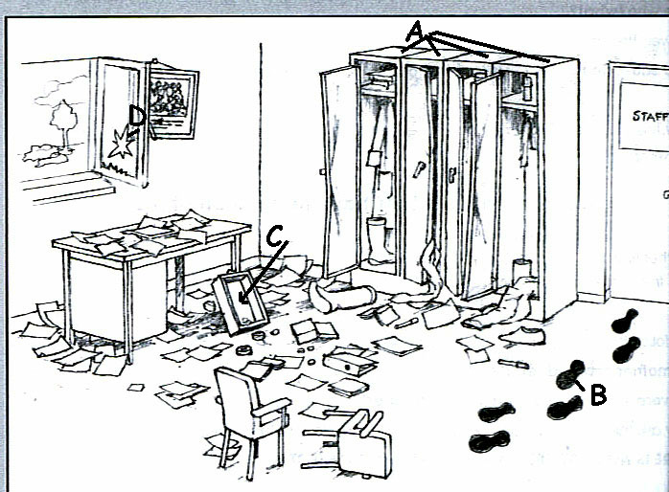
4.5.1 Give one word for A.
4.5.2 Give one word for B.
4.5.3 Give two words for C
4.5.4 Give two words for D
(4)

4.6 Detective Temba has a little notebook with him. Write down the four most important things about the crime scene which you think he would want to remember.
(4)
[15]
QUESTION 5

Read the following episode and answer the questions that follow:

Breaking the rules
I knew something was troubling Izzy the moment I saw him. Usually he never stops talking, but that night I could hardly get a word out of him. Sometimes I’d catch him giving me funny looks too. Once or twice he even forgot his dance steps, which is very unlike him. Izzy’s not just a good dancer, he’s the best in the school. He almost never makes mistakes.
“You’re not concentrating, Izzy,” I said, after he’d stepped on my foot for the third time that evening. “If you don’t concentrate, we’re not going to win the provincial champs, okay?”
I saw him open his mouth to say something, then he seemed to think better of the idea and closed it again. It was when we were walking home together late that evening that he finally told me what was on his mind.
“Karabo, were you in the school grounds on the afternoon of the break-in?” he asked.
I felt my heart miss a beat. “What’s with all the questions?” I blustered.
“Well, were you?”

“Is that what you’ve been thinking about all night? Is that why you were dancing like a complete beginner?”
He didn’t reply. He just looked at me, waiting for me to answer.
“Maybe,” I eventually offered.
“I need to know,” he said seriously.
There were things I needed to know, too. Things about him and Milly, but I wasn’t going to open that particular can of worms. Not until after we’d won the provincials, anyway. After the provincials everything would be different. I mean, what if I made him choose now and he chose Milly? I’d never be able to show my face in school again!.
I gave him a cool look. “Yes, I was,” I said.
“The police are going to charge Joey with the break-in because he was seen in the school grounds on the afternoon in question.”
“So?”
“So you were also on the school grounds that day.”
“Now you’re being ridiculous,” I said angrily. “Joey had a motive for the break-in. No, he had two motives!” And to prove it, I counted them off my fingers. “First of all, he needed money for steroids. And secondly, he wanted to get back at some of the teachers. I don’t have a motive.”
That was a lie, of course. I was being blackmailed over a photograph. And on the weekend of the break-in I knew the photograph was in the staff room. That was why I went to school that afternoon - because I was going to break into the staff room. But someone had got there before me.

The statements below relate to the episode you have just read. Read each statement and decide whether it is true, false, or whether there is not enough evidence to say. Write down the number of the statement and whether it is TRUE, FALSE or NOT ENOUGH EVIDENCE.

5.1 Izzy was being very quiet.
5.2 Izzy was tired
5.3 Karabo was worried.
5.4 Karabo was the best dancer at dance practise.
5.5 Izzy and Karabo danced at provincial level.
5.6 They had entered the provincial championships to be held the following month.
5.7 Karabo was a talkative girl.
5.8 Izzy confronted Karabo.
5.9 Karabo was in the school grounds on the day of the break-in.
5.10 Karabo felt angry.
5.11 Joey had no reason to steal money.
5.12 Karabo had good reason to break into the staff room.
5.13 Izzy is disappointed in his partner.
5.14 Karabo is hiding something
5.15 Bongani got to the staff room before Karabo.
(15)

